**Question 1) How to edit an already existing query in Power Query in excel**

**Steps to Edit an Existing Query in Power Query**

1. **Open Excel and Go to Queries**
   * In Excel, go to the Data tab on the Ribbon.

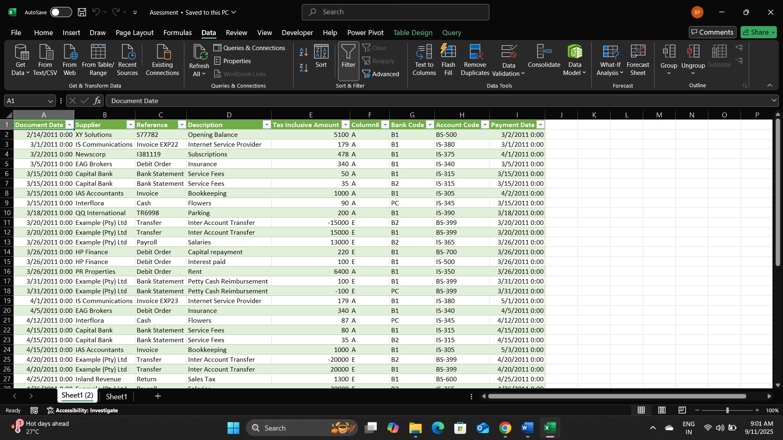

1. **Open the Query Editor**

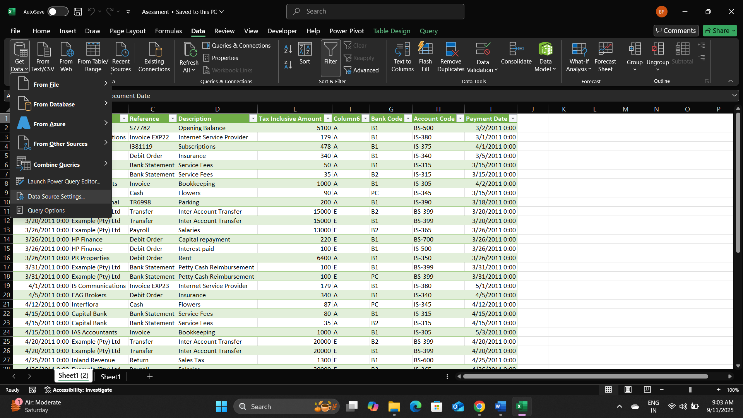

1. **Make the Changes**
   * The Power Query Editor will open.
   * We can:
     + Edit a step
     + Delete a step
     + Reorder steps
     + Add new transformations

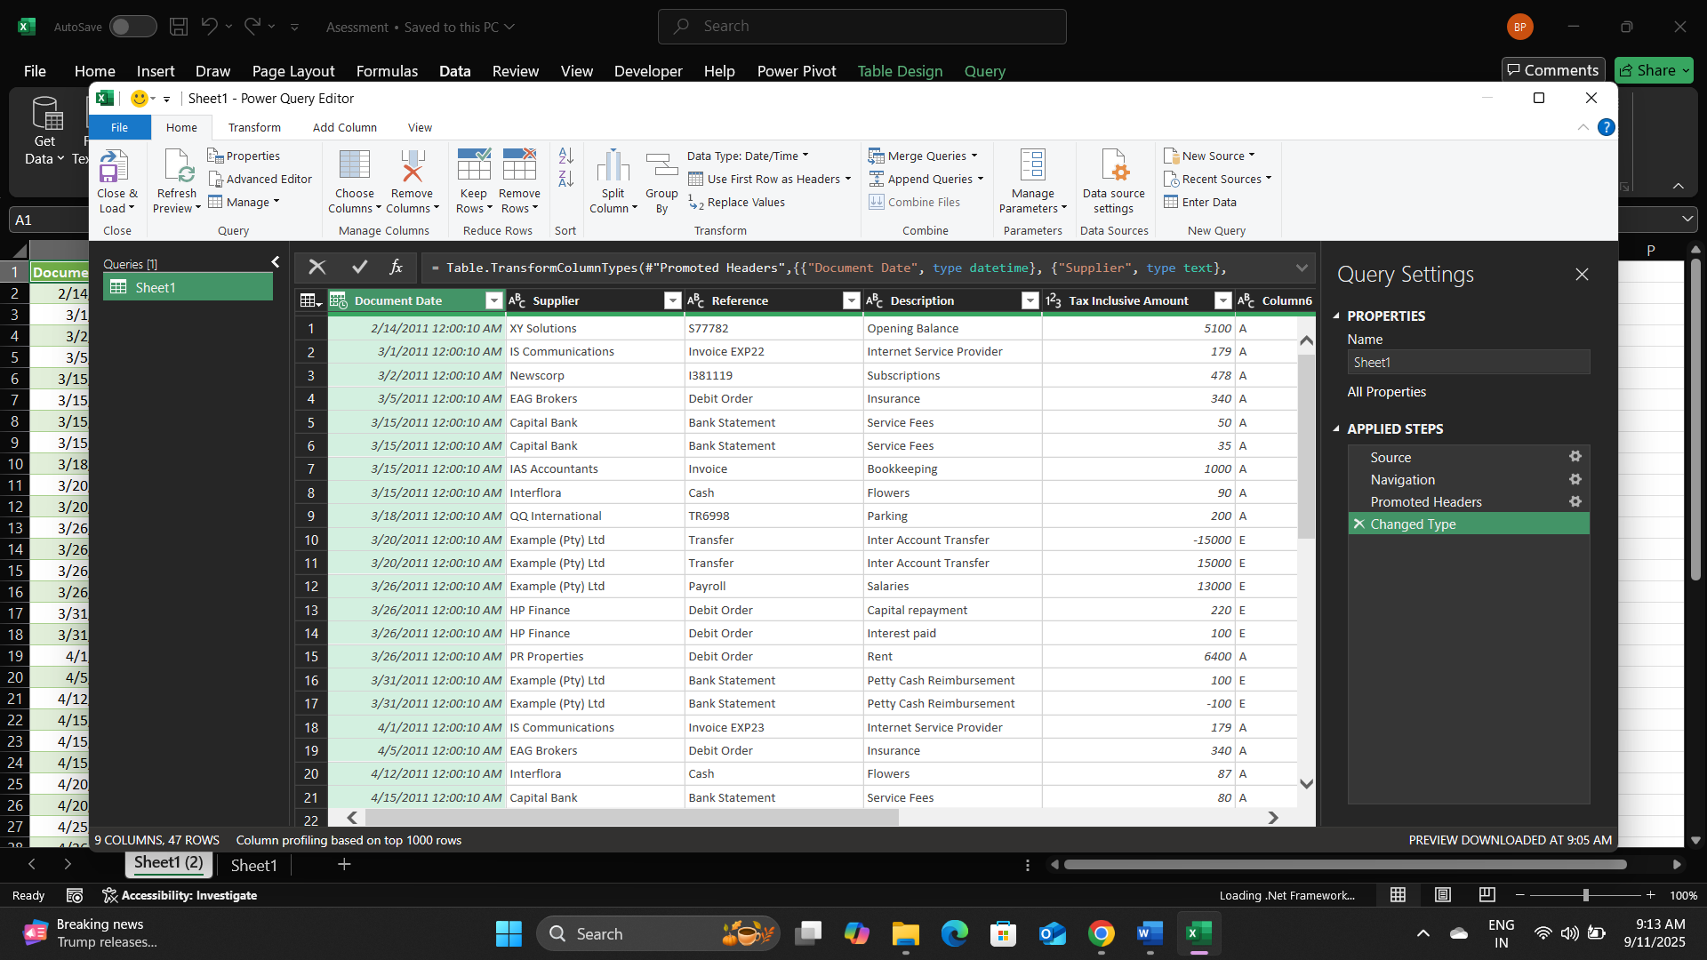

1. **Save and Load**

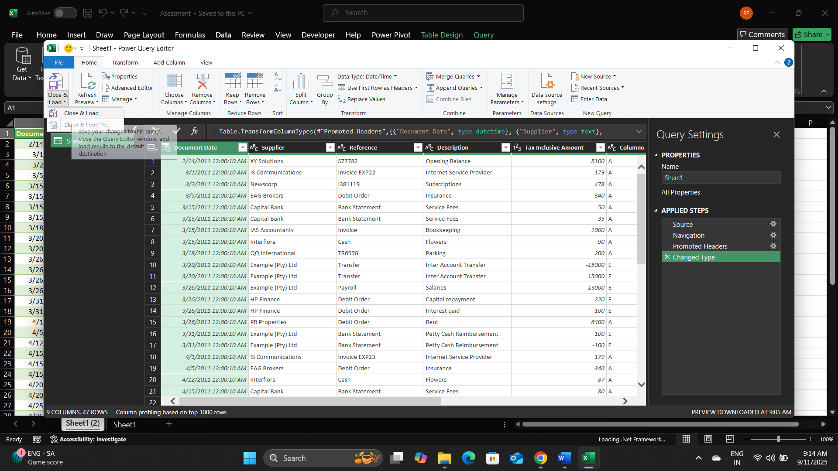

**Question 2) Open the Expenses sheet and note that one of the column headings is blank - we will not be able to create a pivot table which includes all the data on the Expenses sheet if one of the field names that need to be used in our pivot table is blank. Select cell F4 and enter the following heading for the column: Tax Code.**

**Ans: -**

1. Open the Expenses sheet in the Excel file.

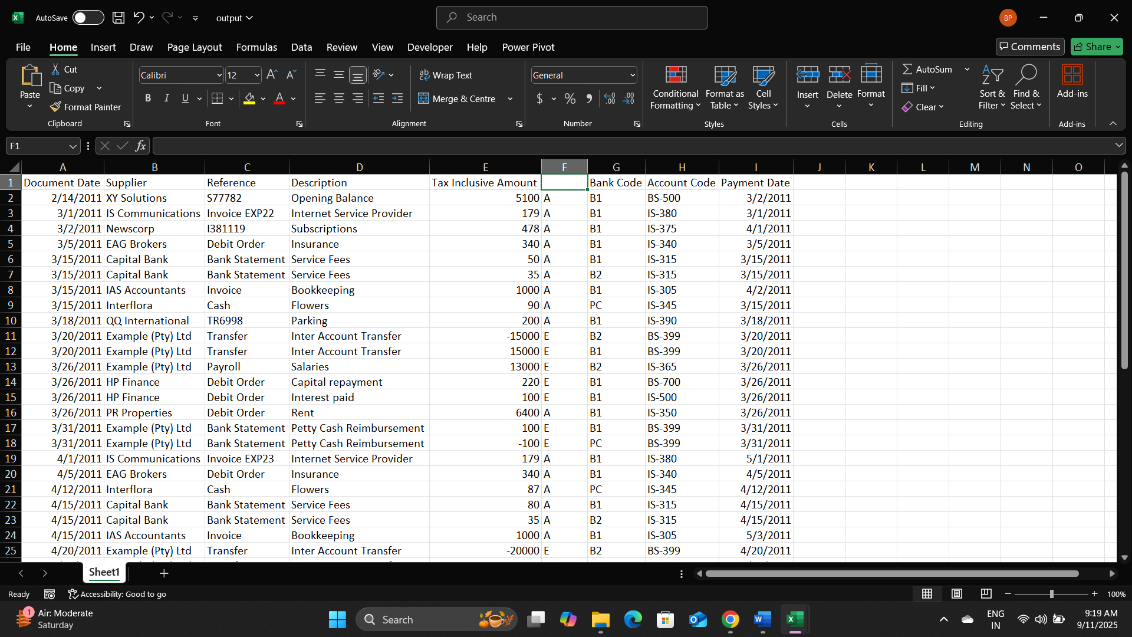

1. Type the heading “Tax heading”

